**Урок 2**

**Часть 1**

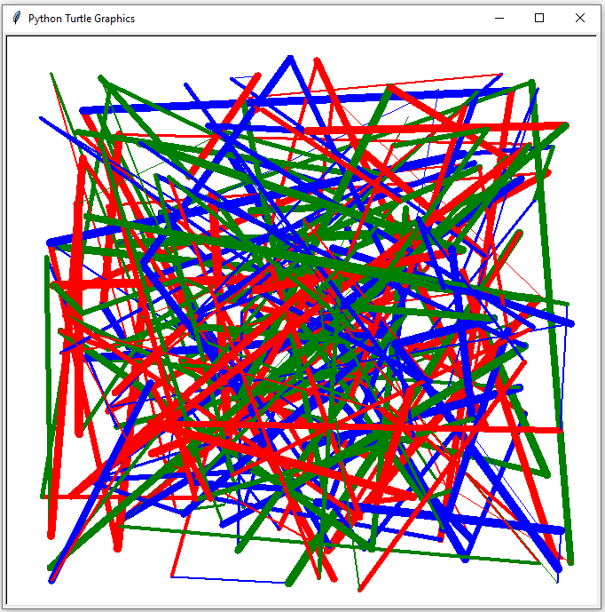import turtle

from random import randint, choice

screen = turtle.Screen()

button = turtle.Turtle()

button.speed(100)

colors = ['red', 'green', 'blue']

def jump():

x = randint(-300, 300)

y = randint(-300, 300)

w = randint(1, 10)

button.color(choice(colors))

button.width(w)

button.goto(x, y)

while 1:

jump()

**Часть 2**

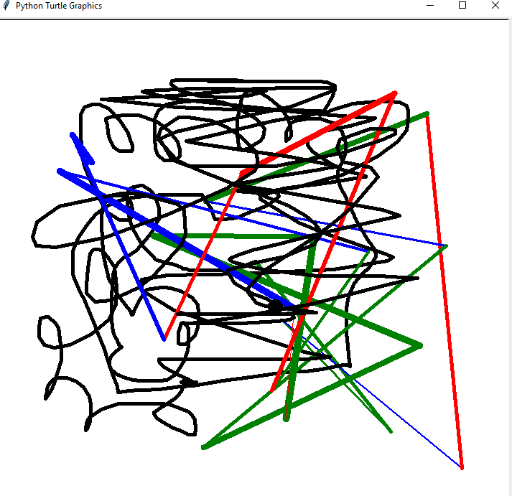

pen = turtle.Turtle()

pen.speed(0)

pen.shape("circle")

pen.up()

pen.width(5)

def draw(mouse_x, mouse_y):

pen.down()

pen.goto(mouse_x, mouse_y)

while 1:

jump()

pen.ondrag(draw)